Open a Chrome Browser Session (preferably Chrome – Microsoft Edge appears to work, but Internet Explorer is currently supported – I have not tested Firefox)

Enter the address:
https://kefron.integration.accountsiq.com/

You should get login screen as illustrated below:

Click “Login”. You will need to provide a valid email address and password for the accountsiq.com domain (such as pmckeown@accountsiq.com – the password will be as provided) (Ellen – this would be your PC log in or your email log in if you use Office365 email).

You will be redirect to the Office365 login as shown below:
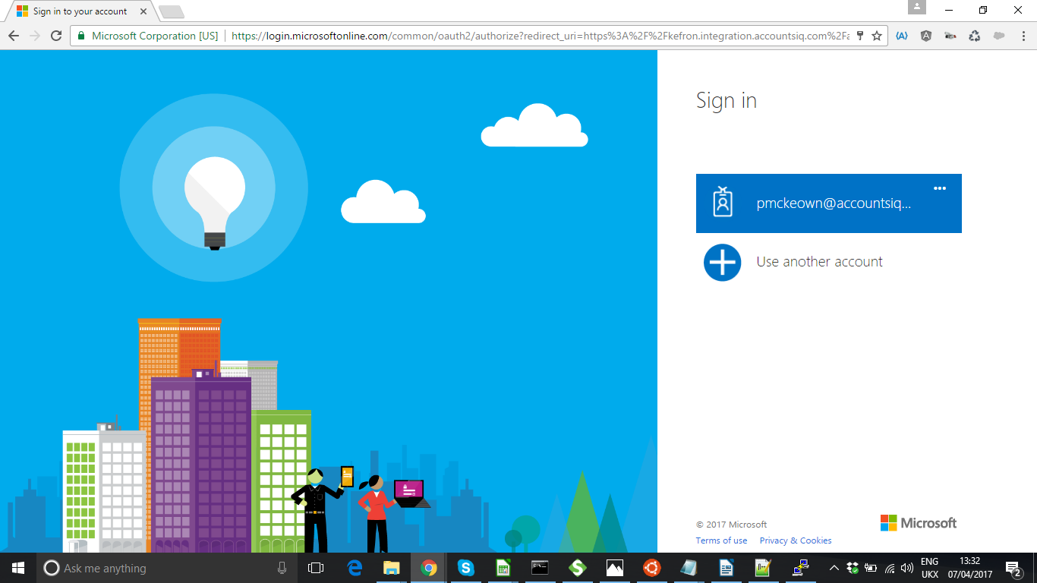

Step 1 – choose a connection:
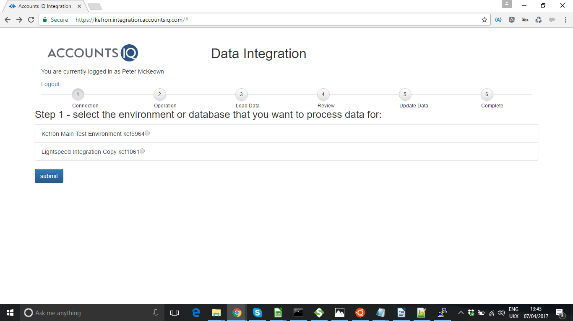
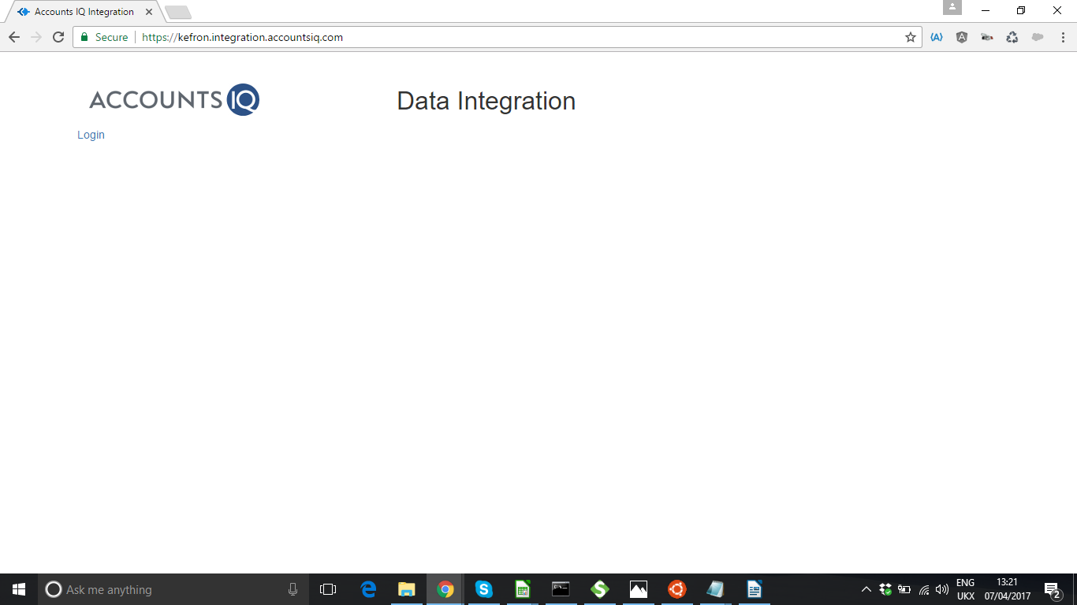
Pick an environment and click “Submit”

Step 2 – choose an integration to run. If you have chosen one that requires a CSV upload. Click “Choose File” and select the CSV file to run and then click “Submit”

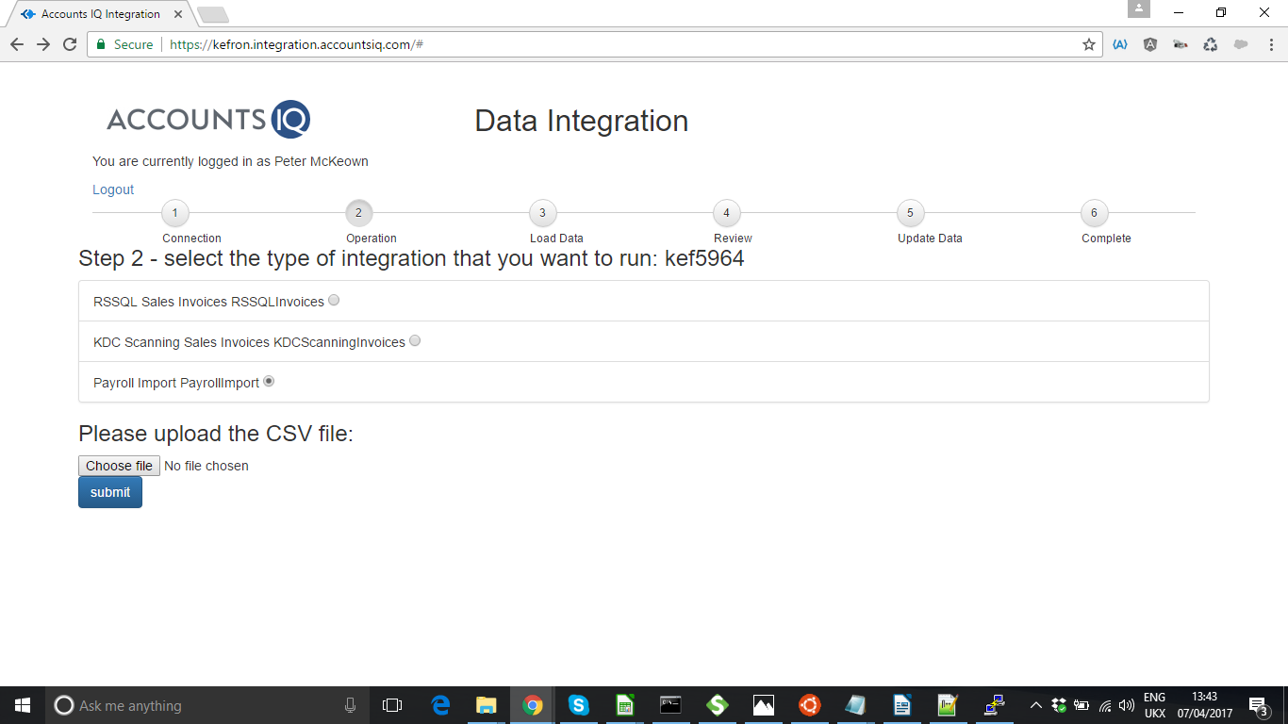
Step 3 – Load Data

The “Refreshing data” table shows the objects (such as GL Code) that need to be validated. The codes that you have currently set up need to be refreshed (so that we can check for any new codes). Whilst the extract is in progress an “refresh” icon will be shown. When the extraction is complete it will show a “tick”. Ideally you should wait until all show a “tick” (but you can proceed if you know that no new data has been set up).

Click “Next – load the data” to proceed.
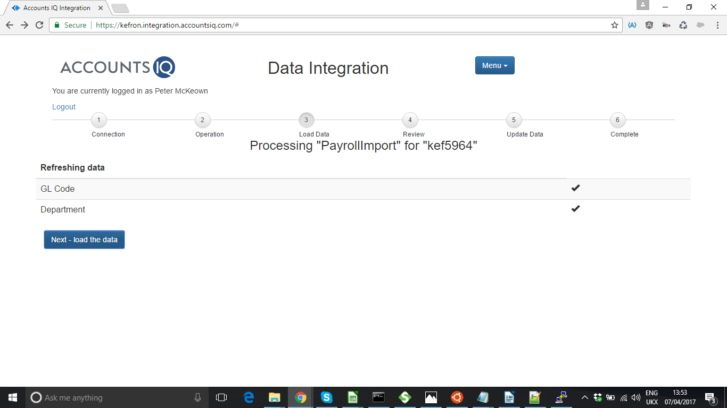

A window will pop up showing the progress of loading the data. The first step is to extract the data from the CSV file and format it to be into the format required for the document(s) to be loaded to accountsIQ. When complete a message will be displayed along with an “OK” button. The number of documents formatted for accountsIQ will also be displayed.

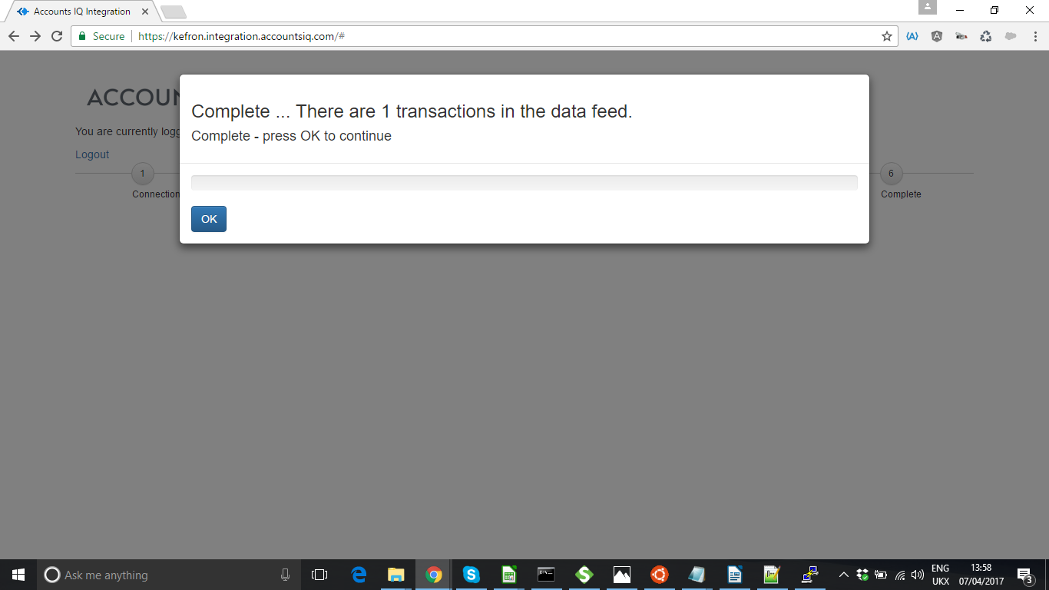
Press OK to return to the main screen. A summary table will show the number of transactions found in the source data (Feed Record Count) – which may not relate to the number of documents to be loaded into accountsIQ if the data feed has “lines”.

It will display the number of transactions (documents to be loaded to accountsIQ), and the number of lines (this should match the number of Feed Transactions if the source data was as “lines”). The number of errors (documents and lines) that failed validation will also be displayed.

If there are any errors they will be displayed in a table. A document will be in error if any of the lines are in error. Errors are usually where the data validation has failed (so a GL Code or Customer Code supplied in the data feed was not found in the extract taken from accountsIQ).
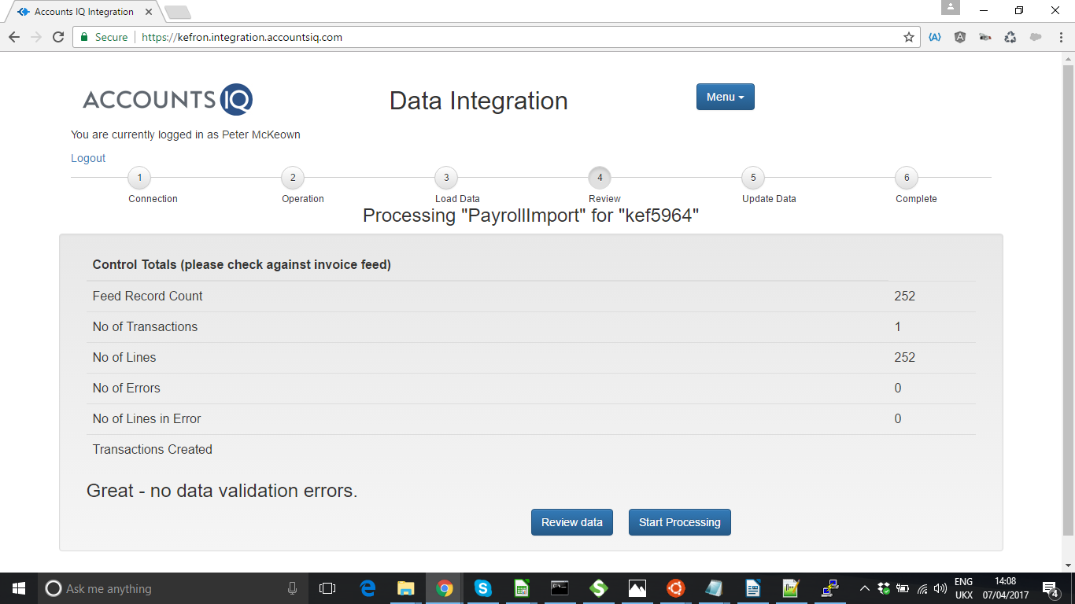
You can review all the transactions by clicking on the “Review Data” button.

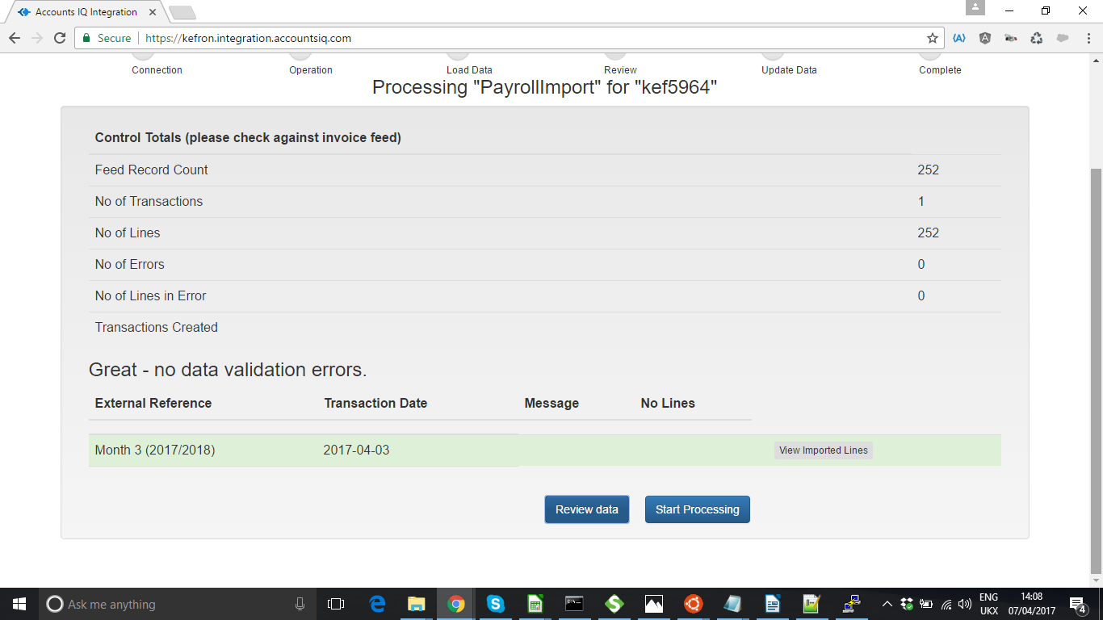
You can use the “View Imported Lines” to see the documents detail as shown below (Ellen – will introduce some paging for the payroll files – but not yet – you can use the scroll bar for the browser to page down to find “OK”/”Cancel” buttons – or use “ESC” to close the pop up window)

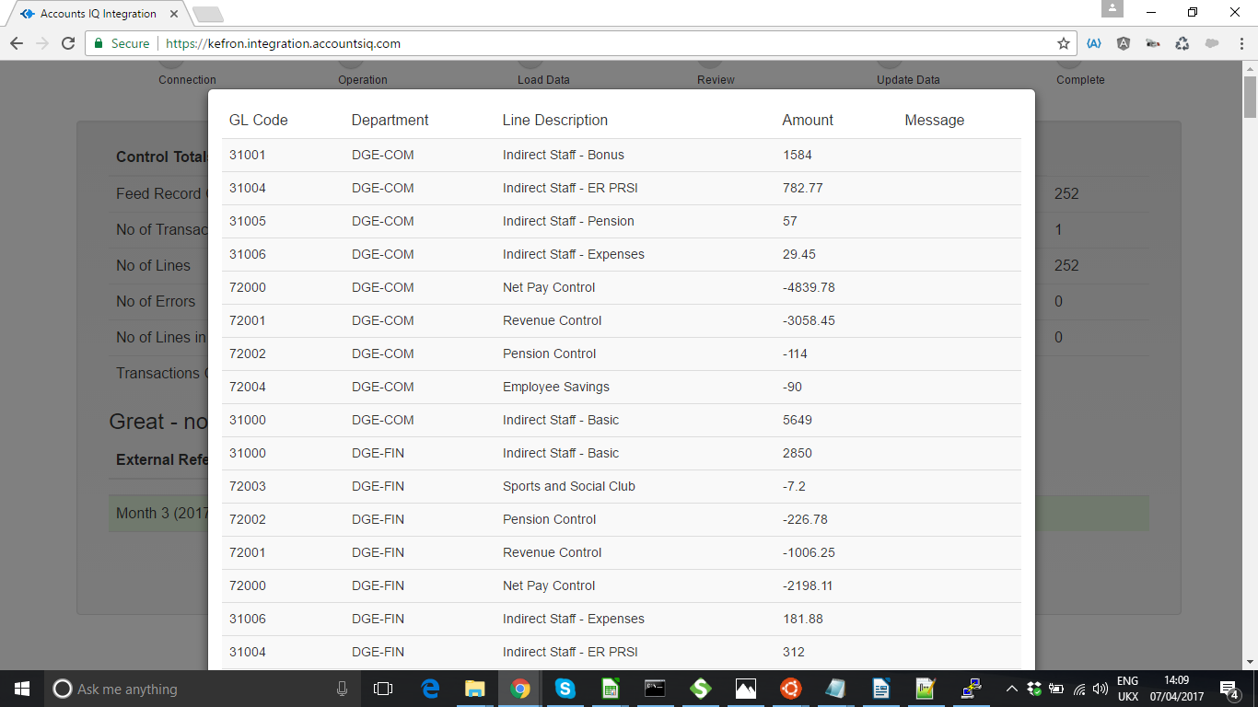

When you have reviewed the data press “Start Processing” to load the data into accountsIQ. Any documents that are in error will NOT be loaded. A pop up window will show the progress.

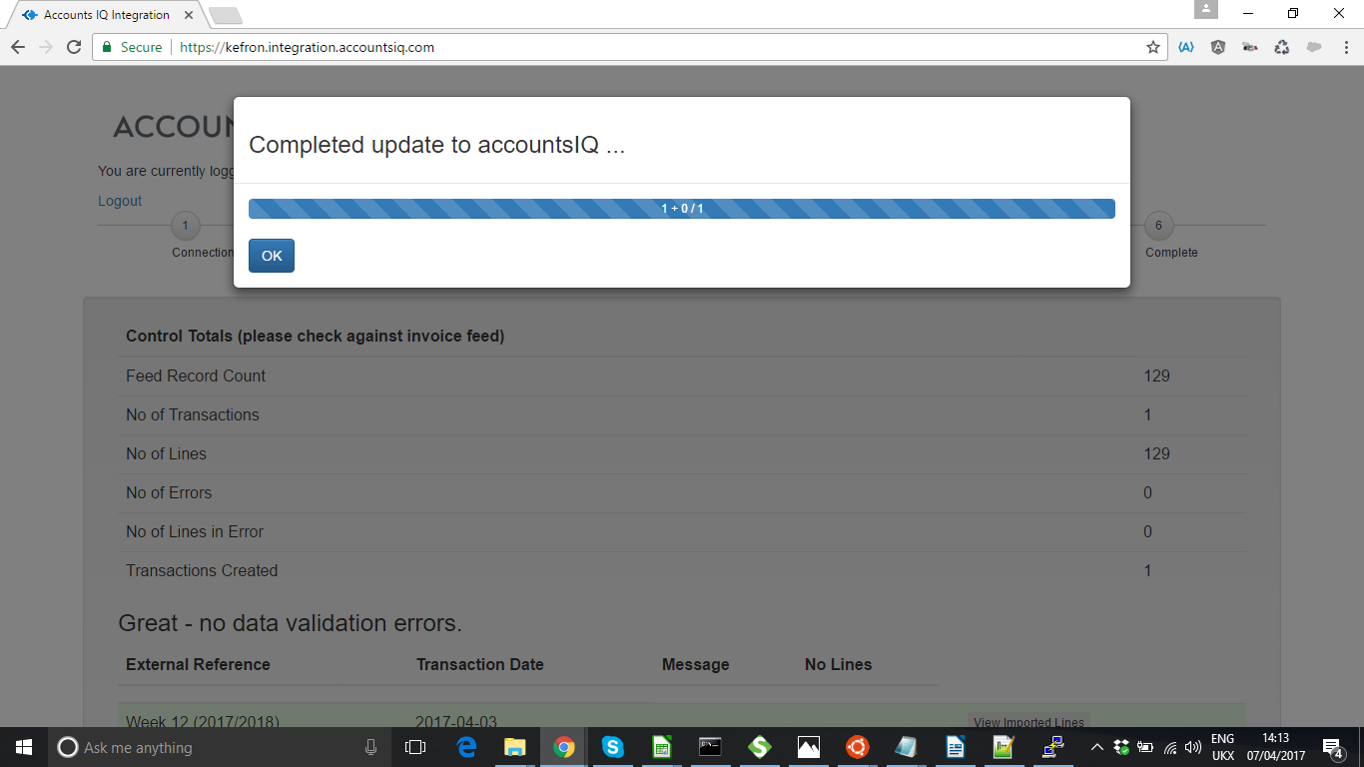
A summary of the data update status will be shown when you press OK. You must review this to ensure that the data has all uploaded

